AWS Systems Manager Parameter Store

What is AWS Systems Manager Parameter Store
AWS Systems Manager Parameter Store is a secure storage service for configuration data and secrets such as:
- API Keys
- Database passwords
- Connection strings
- Application configuration values
It allows applications to retrieve configuration dynamically without hardcoding values in code.

Key Features
- Secure storage of secrets
- Encryption using AWS KMS
- Version control of parameters
- Parameter hierarchy support
- Integration with Lambda, EC2, ECS, CodeBuild

Common Use Cases
1. Storing Database Credentials
Applications retrieve DB username/password securely instead of storing in code.
2. Application Configuration Management
Store environment variables like:
/prod/db/host
/prod/db/password
/dev/api/key
3. Secure Lambda Secrets
Lambda functions can fetch API keys during execution.
4. DevOps Automation
CI/CD pipelines pull configuration during deployments.

Architecture Flow
Application (Lambda / EC2 / ECS)
│
│ Request Parameter
▼
AWS Systems Manager Parameter Store
│
│ Encrypted using KMS
▼
Secure value returned to application
Example:
Lambda → GetParameter API → Parameter Store → KMS decrypt → Value returned

1️⃣ Create a Lambda Function
Step 1 — Open AWS Console
Go to AWS Console → Services → Lambda
Step 2 — Click
Create Function
Step 3 — Select
- Author from scratch

Fill details:
Field | Value
Function name | my-lambda-service
Runtime | Python 3.12
Architecture | x86_64
Click Create Function

2️⃣ Configure IAM Permissions
Lambda needs permissions to access other services.
Step 1
Go to Configuration → Permissions
Step 2
Click Execution Role
Step 3
Attach policies:
- AmazonSSMFullAccess
- AmazonSQSFullAccess
- AWSLambdaBasicExecutionRole
Click Save
Execution Steps (Console)
Step 1
Open AWS Console
Step 2
Go to
Systems Manager
Step 3
Select
Parameter Store
Step 4
Click
Create Parameter

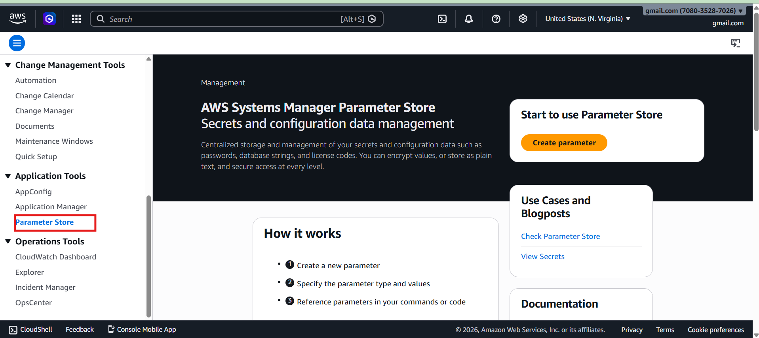
Step 5
Enter
Name
/prod/db/password
Type
SecureString
Value
mypassword123
Encryption
AWS KMS
Step 6
Save parameter

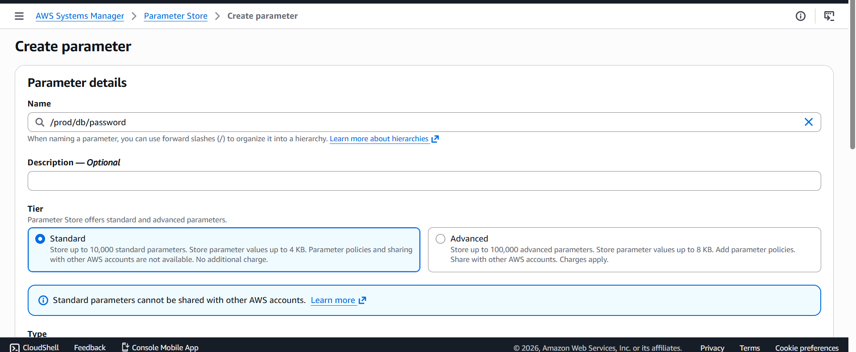

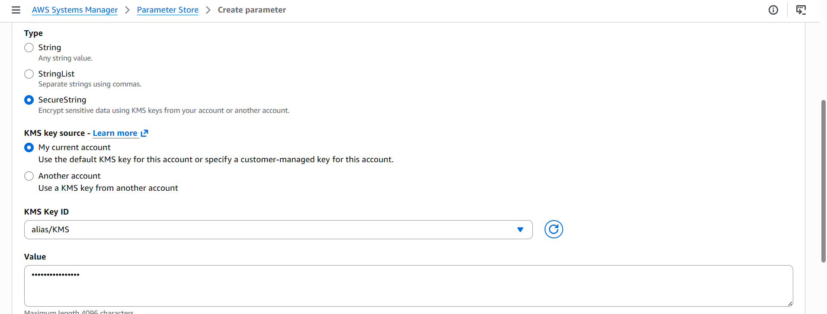

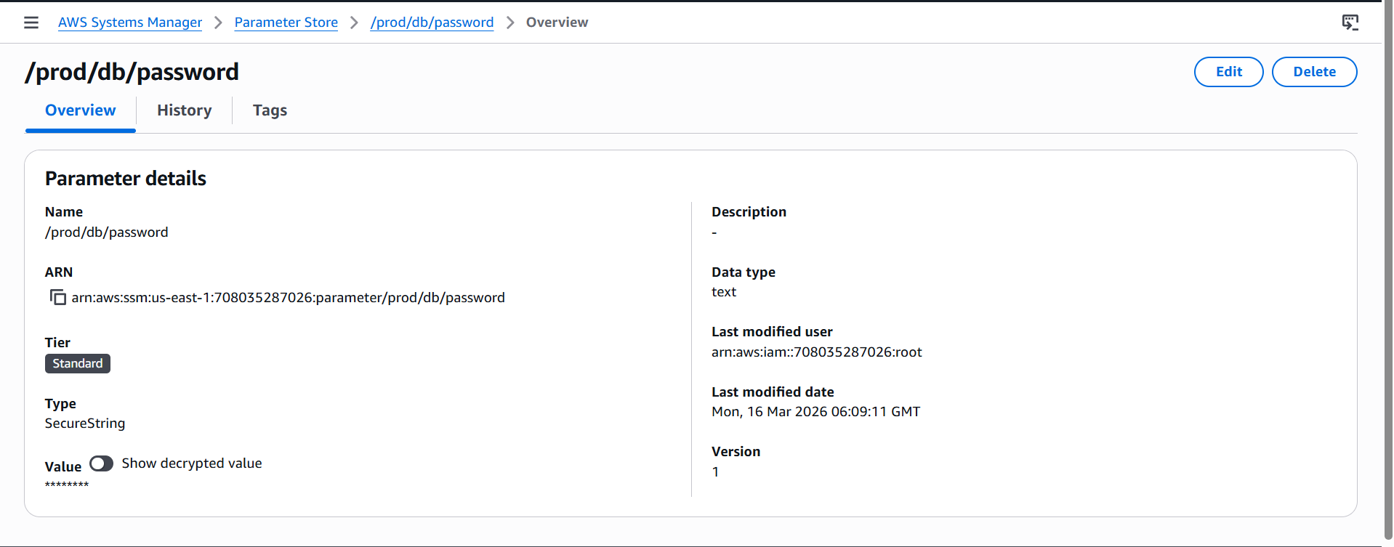

Open IAM
- Go to AWS Console
- Search IAM
- Click Roles
- Search and open:
my-lambda-service-role-8mtndfbc
Click Add inline policy
Paste this JSON:
{
"Version": "2012-10-17",
"Statement": [
{
"Effect": "Allow",
"Action": [
"ssm:GetParameter",
"ssm:GetParameters"
],
"Resource": "*"
},
{
"Effect": "Allow",
"Action": [
"kms:Decrypt"
],
"Resource": "*"
}
]
}

Program 1 — Retrieving Parameter (Example Lambda Python)
import boto3
ssm = boto3.client('ssm')
def lambda_handler(event, context):
response = ssm.get_parameter(
Name='/prod/db/password',
WithDecryption=True
)
password = response['Parameter']['Value']
print(password)
return {
"statusCode": 200,
"body": password
}

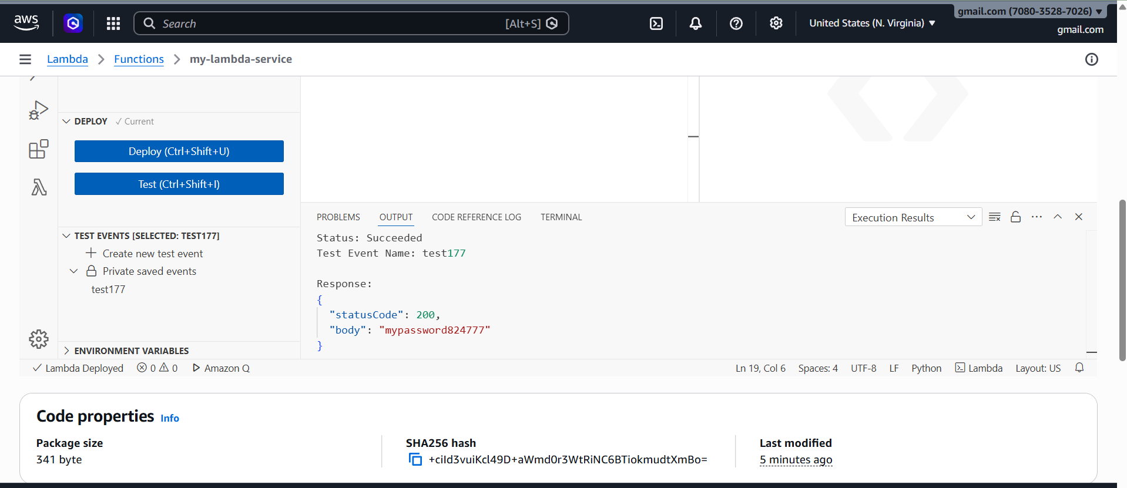
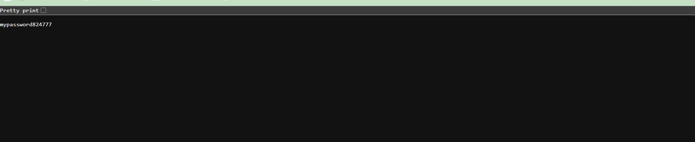
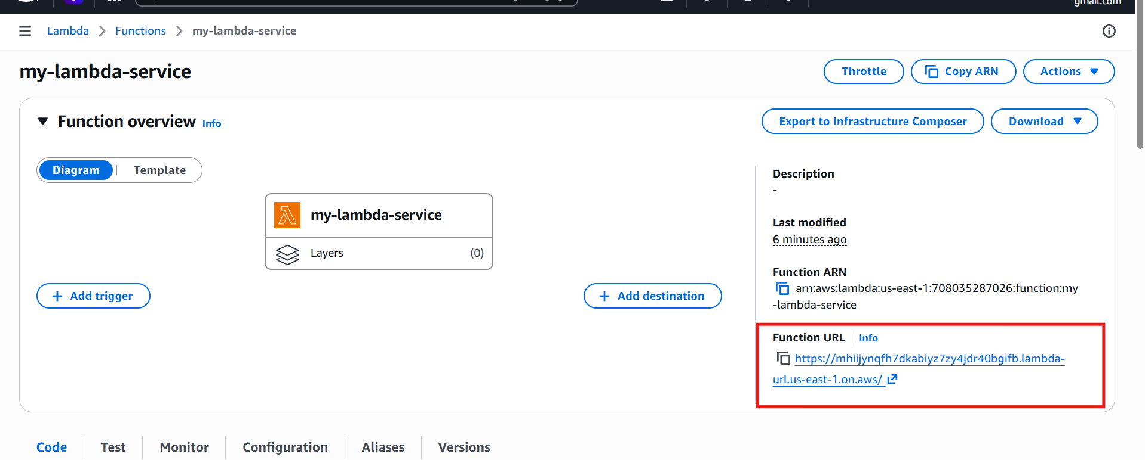

Flow
Application
↓
Parameter Store
↓
KMS decrypt
↓
Secret returned
Program 2 — Store a Parameter (Create Secret)
✅ Add KMS Encrypt Permission
1️⃣ Open IAM
- Go to AWS Console
- Search IAM
- Click Roles
- Open your role:
my-lambda-service-role-8mtndfbc

2️⃣ Add Inline Policy
Click:
Add permissions → Create inline policy
Choose JSON and paste:
{
"Version": "2012-10-17",
"Statement": [
{
"Effect": "Allow",
"Action": [
"ssm:GetParameter",
"ssm:GetParameters",
"ssm:PutParameter"
],
"Resource": "*"
},
{
"Effect": "Allow",
"Action": [
"kms:Encrypt",
"kms:Decrypt",
"kms:GenerateDataKey"
],
"Resource": "*"
}
]
}
Click Review → Create policy
import boto3
ssm = boto3.client('ssm')
def lambda_handler(event, context):
response = ssm.put_parameter(
Name='/prod/db/password',
Value='MySecurePassword123',
Type='SecureString',
Overwrite=True
)
print("Parameter stored successfully")
return response
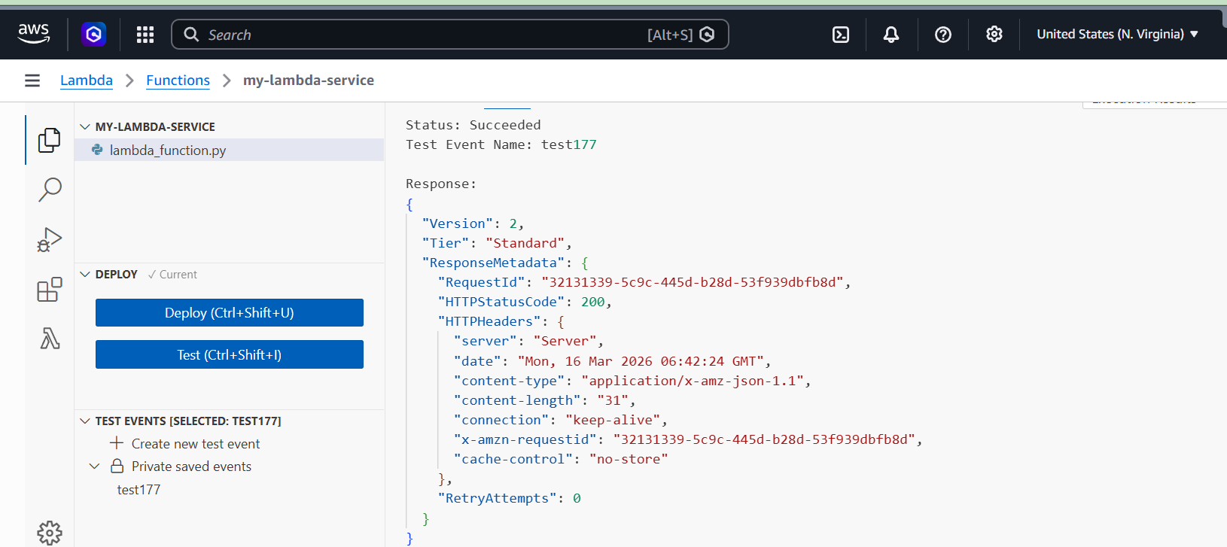
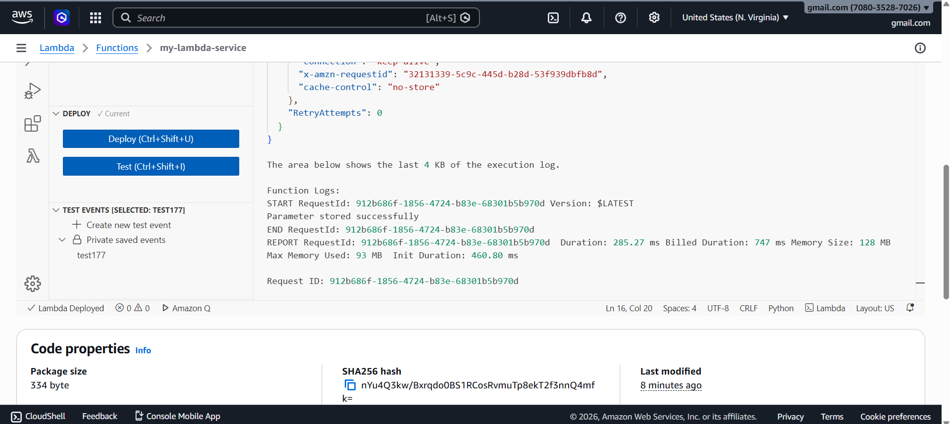
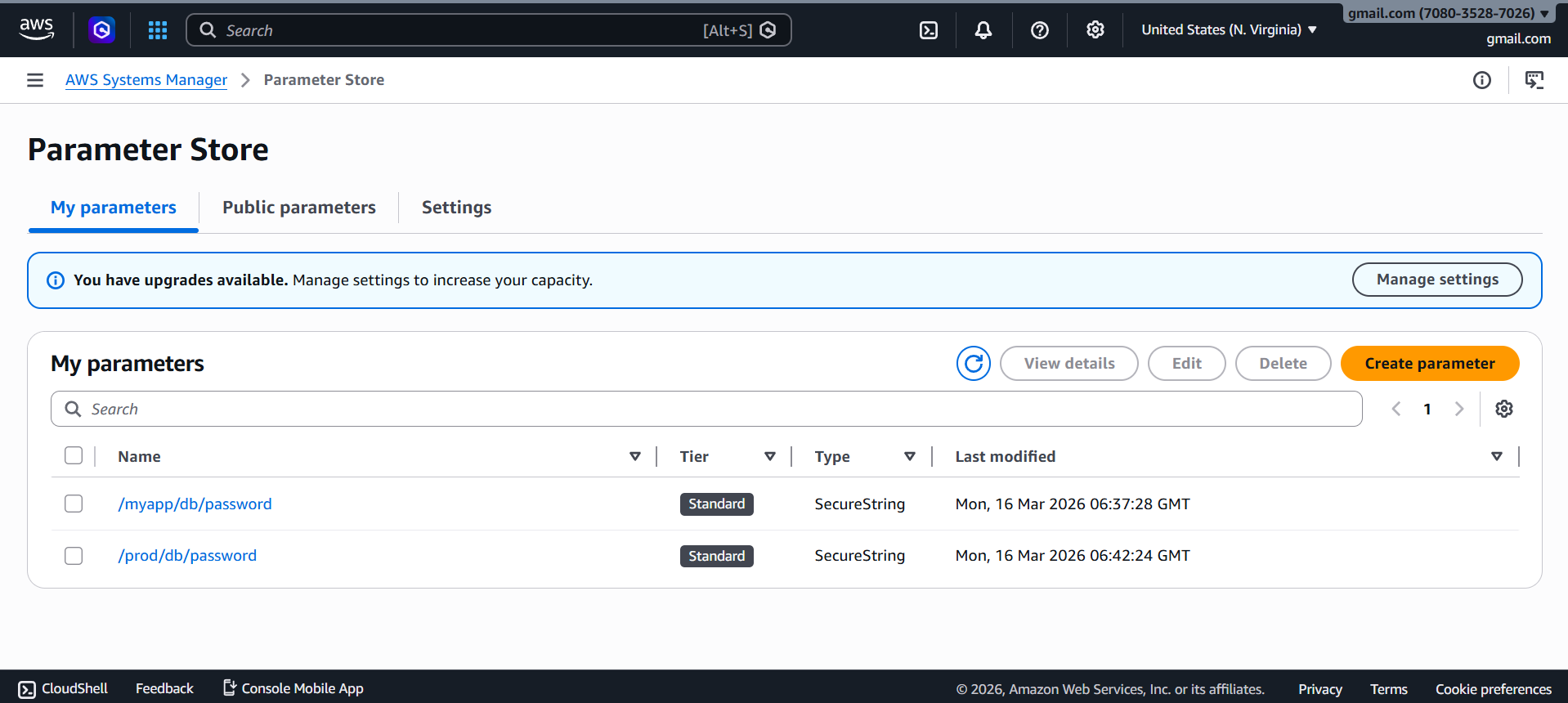

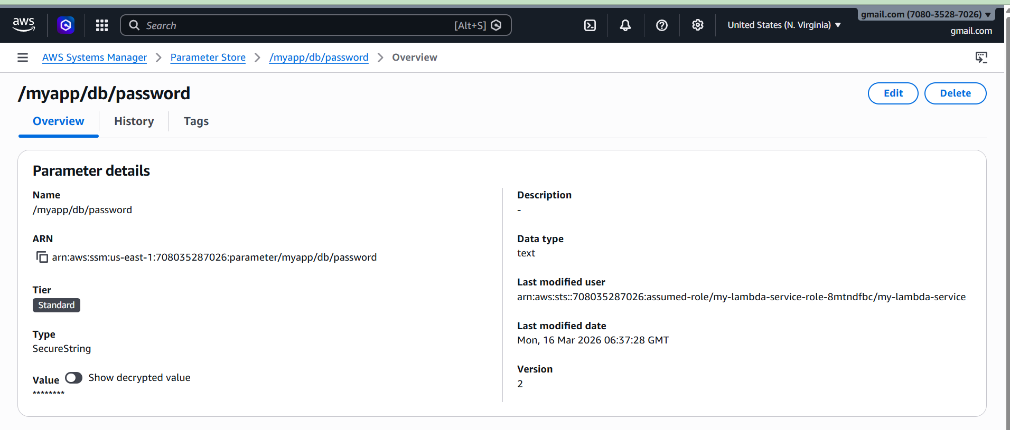

What it does
- Connects to Parameter Store
- Creates a secure parameter
- Stores encrypted password

AWS Web Application Firewall (WAF)

What is AWS WAF
AWS WAF is a security service that protects web applications from malicious traffic such as:
- SQL Injection
- Cross Site Scripting (XSS)
- Bot attacks
- DDoS layer 7 attacks
It filters HTTP requests before reaching your application.

Key Features
- IP blocking
- Rate limiting
- SQL injection protection
- XSS protection
- Managed security rules
- Bot control

Where AWS WAF Can Be Used
AWS WAF can protect:
- CloudFront
- Application Load Balancer
- API Gateway
- AppSync

Use Cases
1. Protecting APIs
Client → WAF → API Gateway → Lambda
Blocks malicious API requests.

2. Prevent SQL Injection
Example attack request:
login.php?id=1 OR 1=1
WAF blocks it.

3. Rate Limiting
Prevent bots sending thousands of requests.
Example:
Allow only 2000 requests per 5 minutes per IP

Architecture Flow
User Request
│
▼
AWS WAF
│
│ Check Rules
│
├── Block (malicious)
│
└── Allow
│
▼
Application (ALB / API Gateway / CloudFront)
│
▼
Backend (Lambda / EC2)

Execution Steps
Step 1
Open AWS Console
Step 2
Search
AWS WAF
Step 3
Click
Create Web ACL

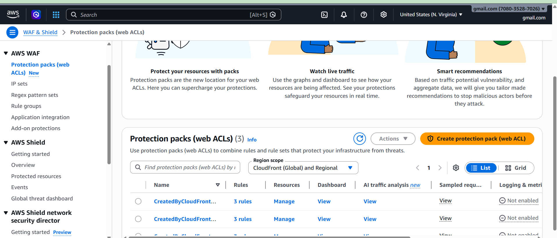

Step 4
Choose resource
Example
API Gateway
or
Application Load Balancer

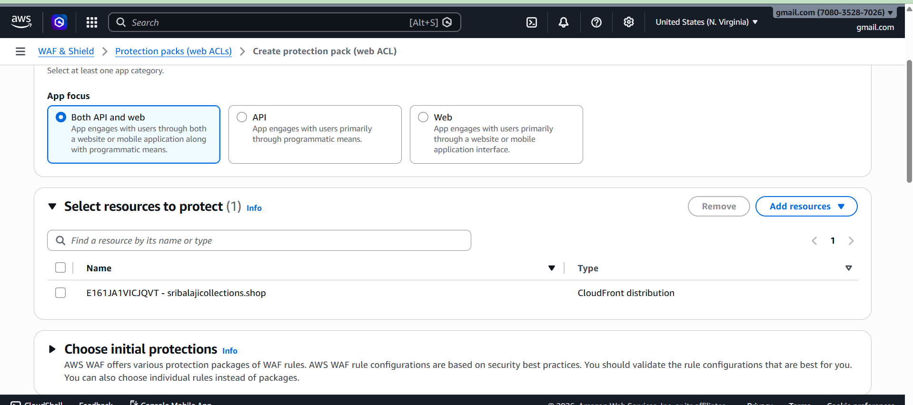
Step 5
Add rules
Examples:
- SQL injection rule
- XSS rule
- Rate limit rule
- IP block rule
Step 6
Attach Web ACL to resource
Example
API Gateway
CloudFront
ALB
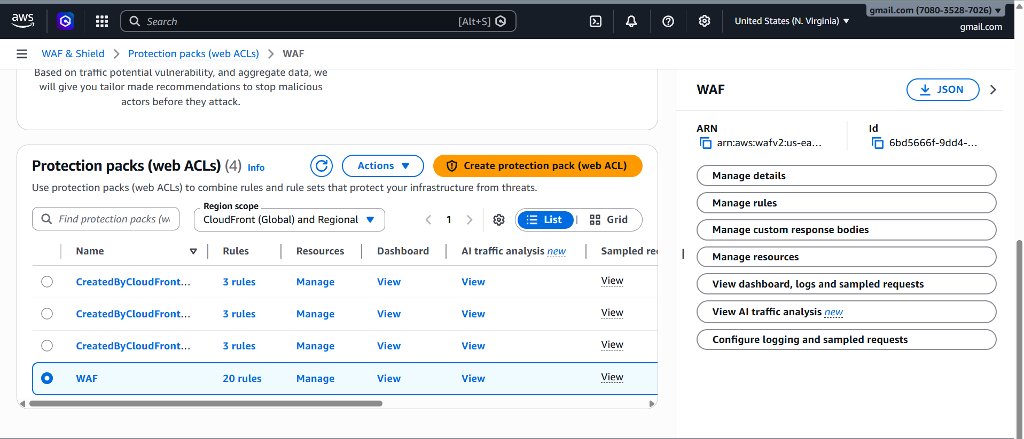

Architecture Flow
User
↓
AWS WAF
↓
API Gateway
↓
Lambda
↓
Database / SQS

AWS Web Application Firewall (WAF)
1️⃣ Prerequisites
Before running the Python programs, make sure these are ready.
Install boto3
pip install boto3
Configure AWS credentials
aws configure
Enter
AWS Access Key
AWS Secret Key
Region (ex: ap-south-1)
Output format: json
Required IAM Permission
Your IAM user must allow:
wafv2:CreateWebACL
wafv2:UpdateWebACL
wafv2:AssociateWebACL
wafv2:GetWebACL

Check Existing WebACL First (Professional Method)
Better production code checks if the ACL exists before creating.
import boto3
import json
def lambda_handler(event, context):
waf = boto3.client('wafv2', region_name='ap-south-1')
acls = waf.list_web_acls(
Scope='REGIONAL'
)
for acl in acls['WebACLs']:
if acl['Name'] == 'MyWebACL':
return {
'statusCode': 200,
'body': "Web ACL already exists"
}
response = waf.create_web_acl(
Name='MyWebACL',
Scope='REGIONAL',
DefaultAction={'Allow': {}},
VisibilityConfig={
'SampledRequestsEnabled': True,
'CloudWatchMetricsEnabled': True,
'MetricName': 'MyWebACLMetric'
},
Rules=[]
)
return {
'statusCode': 200,
'body': "Web ACL Created"
}

Program 1 — Create Web ACL

import boto3
import json
def lambda_handler(event, context):
waf = boto3.client('wafv2', region_name='ap-south-1')
web_acl_name = "MyWebACL-Vignesh"
try:
# Check existing Web ACLs
response = waf.list_web_acls(
Scope='REGIONAL'
)
for acl in response['WebACLs']:
if acl['Name'] == web_acl_name:
return {
"statusCode": 200,
"body": json.dumps("Web ACL already exists")
}
# Create Web ACL if not exists
create_response = waf.create_web_acl(
Name=web_acl_name,
Scope='REGIONAL',
DefaultAction={'Allow': {}},
Description='Demo WAF created from Lambda',
VisibilityConfig={
'SampledRequestsEnabled': True,
'CloudWatchMetricsEnabled': True,
'MetricName': 'MyWebACLMetric'
},
Rules=[]
)
return {
"statusCode": 200,
"body": json.dumps("Web ACL created successfully")

except Exception as e:
return {
"statusCode": 500,
"body": json.dumps(str(e))
}
Next Step (Now add a Security Rule)
Your Web ACL currently has no protection rules.
Now we add a Rate Limit Rule (protects against bots and DDoS).
Updated Lambda Code — Add Rate Limit Rule

import boto3
import json
def lambda_handler(event, context):
waf = boto3.client('wafv2', region_name='ap-south-1')
web_acl_name = "MyWebACL-Vignesh"
web_acl_id = "6bd5666f-9dd4-4b10-a3e6-96c895552a91"
response = waf.get_web_acl(
Name=web_acl_name,
Scope='REGIONAL',
Id=web_acl_id
)
lock_token = response['LockToken']
rules = response['WebACL']['Rules']
rules.append({
'Name': 'RateLimitRule',
'Priority': 1,
'Statement': {
'RateBasedStatement': {
'Limit': 2000,
'AggregateKeyType': 'IP'
}
},
'Action': {'Block': {}},
'VisibilityConfig': {
'SampledRequestsEnabled': True,
'CloudWatchMetricsEnabled': True,
'MetricName': 'RateLimitMetric'
}
})
waf.update_web_acl(
Name=web_acl_name,
Scope='REGIONAL',
Id=web_acl_id,
DefaultAction={'Allow': {}},
Rules=rules,
VisibilityConfig={
'SampledRequestsEnabled': True,
'CloudWatchMetricsEnabled': True,
'MetricName': 'MyWebACLMetric'
},
LockToken=lock_token
)
return {
"statusCode": 200,
"body": json.dumps("Rate limit rule added successfully")
}

What This Rule Does
If an IP sends more than 2000 requests in 5 minutes, WAF will:
BLOCK the IP
Protects against:
- Bot traffic
- API abuse
- Layer-7 DDoS
- Brute-force login attacks

Final Architecture of Your Project
User
│
Internet
│
AWS WAF
│
API Gateway
│
Lambda
│
DynamoDB
WAF filters malicious traffic before it reaches Lambda.

Run Program
python create_waf_acl.py

Output
It returns something like:
WebACLArn
WebACLId

Example:
arn:aws:wafv2:ap-south-1:123456:webacl/MyWebACL
Save this ARN and ID.

3️⃣ Verify in AWS Console
Go to
AWS Console → WAF & Shield → Web ACLs
You will see
MyWebACL
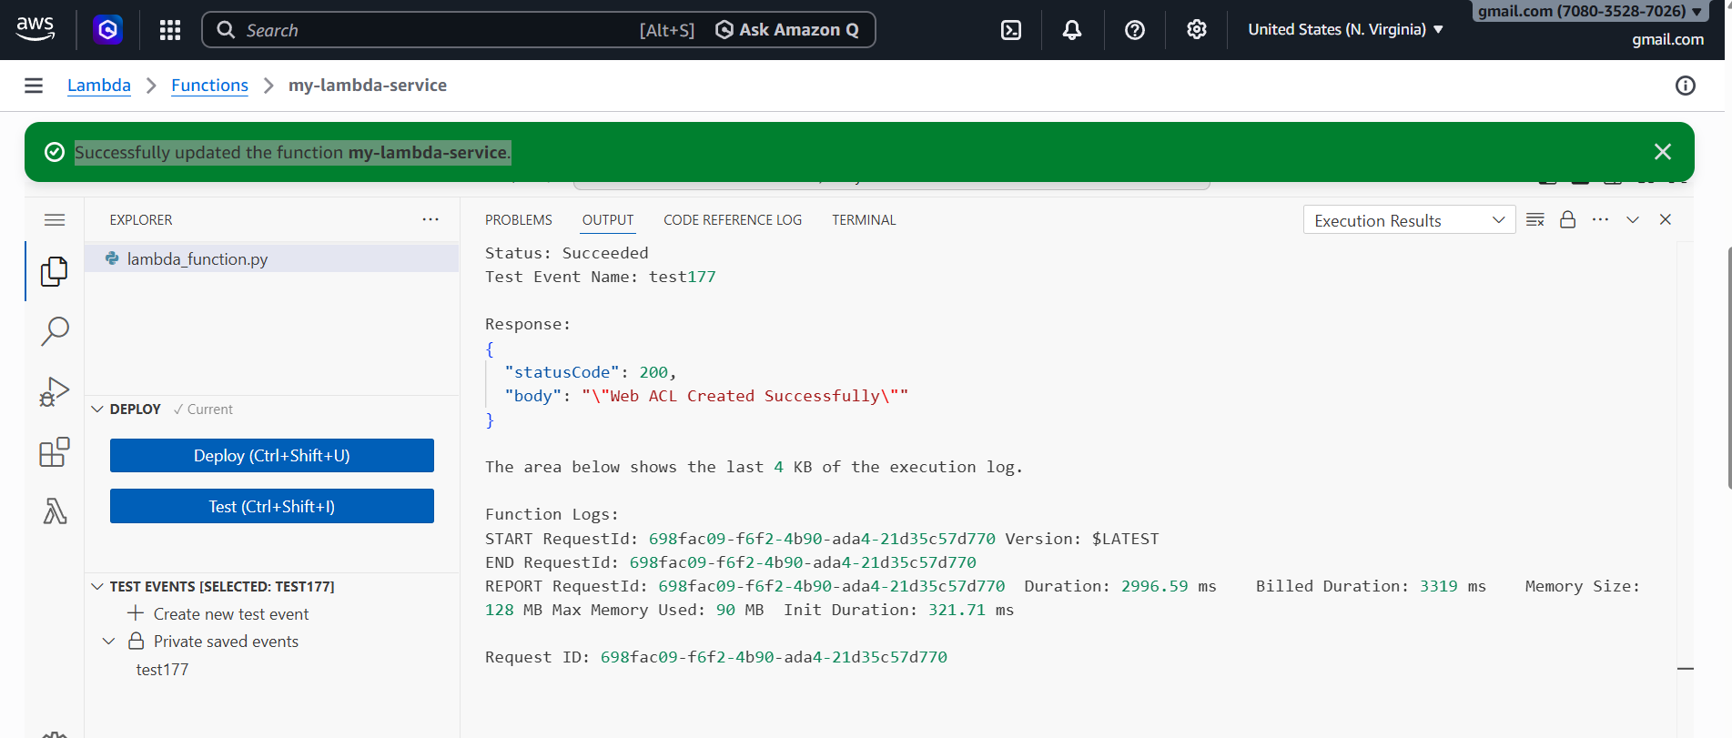

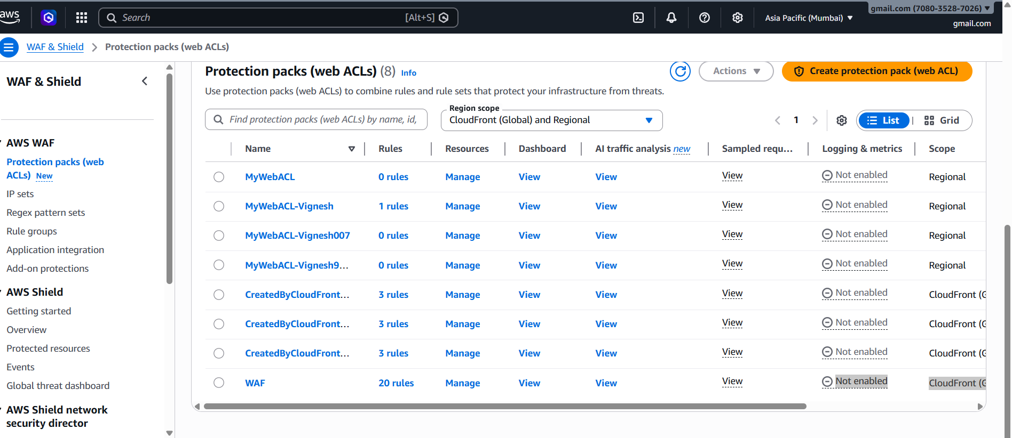

1️⃣ Create WebACL
2️⃣ Add SQL Injection Rule
3️⃣ Add XSS Protection
4️⃣ Add Rate Limit Rule
5️⃣ Attach WAF to API Gateway

AWS SQS and Amazon MQ
Both services are message queue services used for communication between applications.

Amazon SQS (Simple Queue Service)

What is Amazon SQS
Amazon SQS is a fully managed message queue service used to decouple microservices.
Applications send messages to a queue and other services process them asynchronously.

Key Features
- Fully managed
- Highly scalable
- Message durability
- At least once delivery
- Dead Letter Queue support

SQS Types

Standard Queue
- Unlimited throughput
- At least once delivery
- Possible duplicate messages

FIFO Queue
- Exactly once processing
- Ordered messages
Example:
Order1 → Order2 → Order3

Use Case Example (Food Order System)
Customer places order.
User → Order API → SQS Queue → Worker Service → Database
Benefits:
- Handles traffic spikes
- Prevents server overload

Architecture Flow
- User
│
▼
API Gateway
│
▼
Lambda
│
▼
SQS Queue
│
▼
Worker Lambda / EC2
│
▼
Database

Execution Steps
Step 1
Open AWS Console
Step 2
Search
SQS
Step 3
Click
Create Queue
Step 4
Choose queue type
Standard
or
FIFO
Step 5
Enter queue name
Example
order-queue
Step 6
Create queue
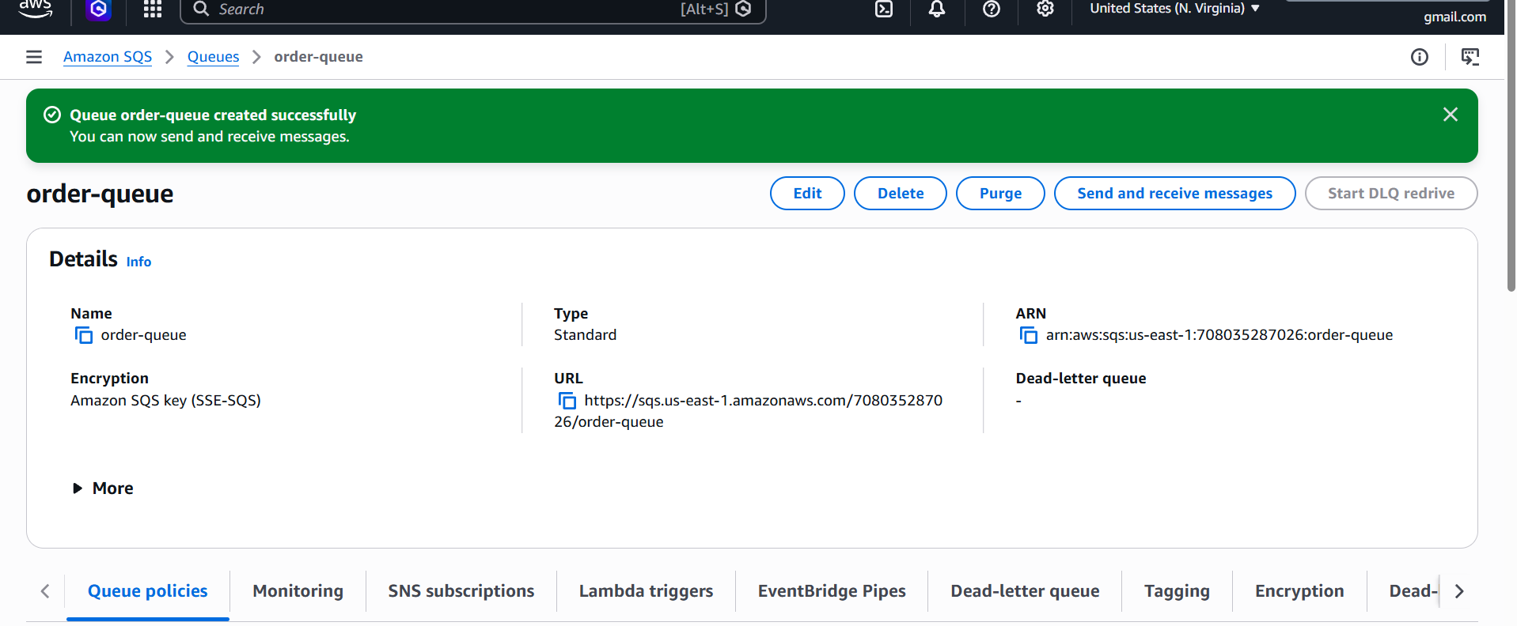
Program 1 -Sending Message Example (Python)
import boto3
sqs = boto3.client('sqs', region_name='us-east-1')
queue_url = "https://sqs.us-east-1.amazonaws.com/708035287026/order-queue"
def lambda_handler(event, context):
response = sqs.send_message(
QueueUrl=queue_url,
MessageBody='New Order: Product ID 123'
)
print("Message Sent Successfully")
print(response)
return {
"statusCode": 200,
"body": "Message sent to SQS successfully"
}
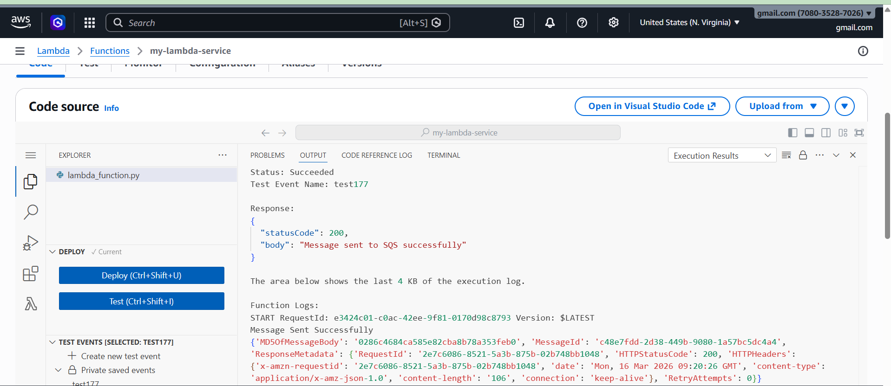

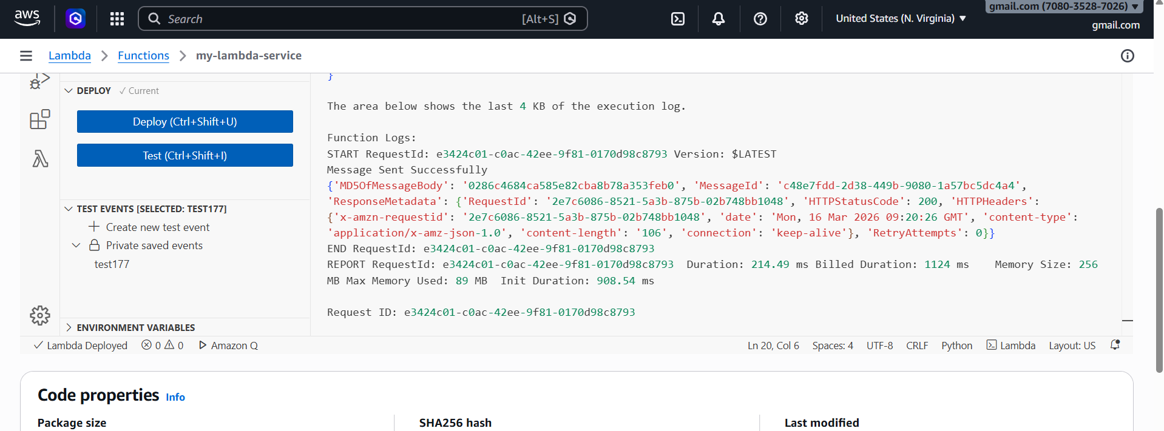

1️⃣ Open Amazon SQS
- Go to AWS Console
- Search SQS
- Click Simple Queue Service

2️⃣ Open Your Queue
- Find your queue:
- myqueue-1
- or
- order-queue
- Click the queue name.

3️⃣ Go to “Send and receive messages”
Inside the queue page:
Click
Send and receive messages

4️⃣ Poll Messages
Scroll down and click:
Poll for messages
AWS will retrieve messages currently in the queue.
You should see something like:
New Order: Product ID 123
or your message body.

5️⃣ View Message Details
Click the message.
You will see:
Field | Meaning
Message Body | Actual message
Message ID | Unique message ID
Sent Timestamp | When message was sent

Program 2 — Receive Message from Queue

import boto3
sqs = boto3.client('sqs')
queue_url = "https://sqs.us-east-1.amazonaws.com/708035287026/order-queue"
def lambda_handler(event, context):
response = sqs.receive_message(
QueueUrl=queue_url,
MaxNumberOfMessages=1
)
messages = response.get('Messages', [])
for message in messages:
print("Received:", message['Body'])
sqs.delete_message(
QueueUrl=queue_url,
ReceiptHandle=message['ReceiptHandle']
)
return {
"statusCode": 200,
"body": "Message received and deleted"
}

This pulls messages from the queue.
Parameter meaning:
Parameter | Purpose
QueueUrl | Queue address
MaxNumberOfMessages | Number of messages to retrieve

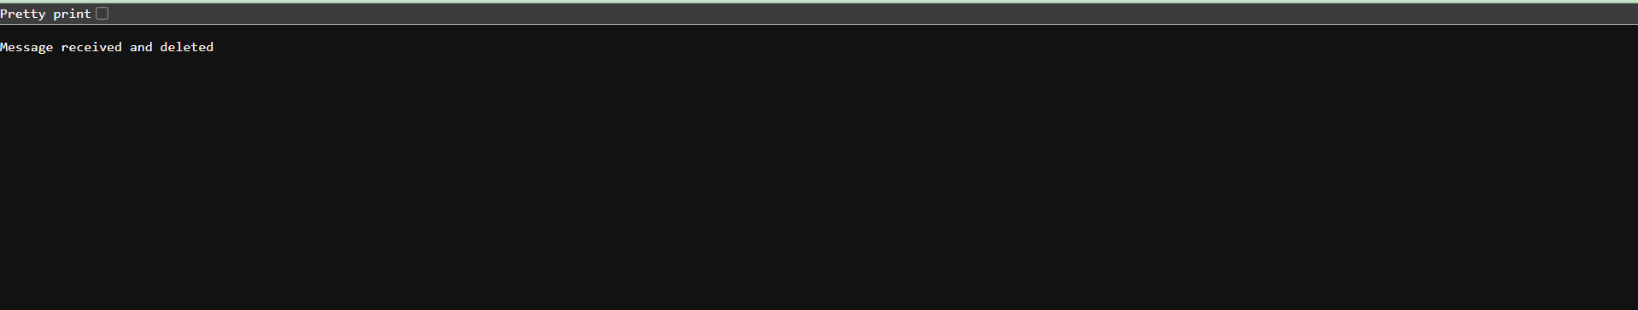

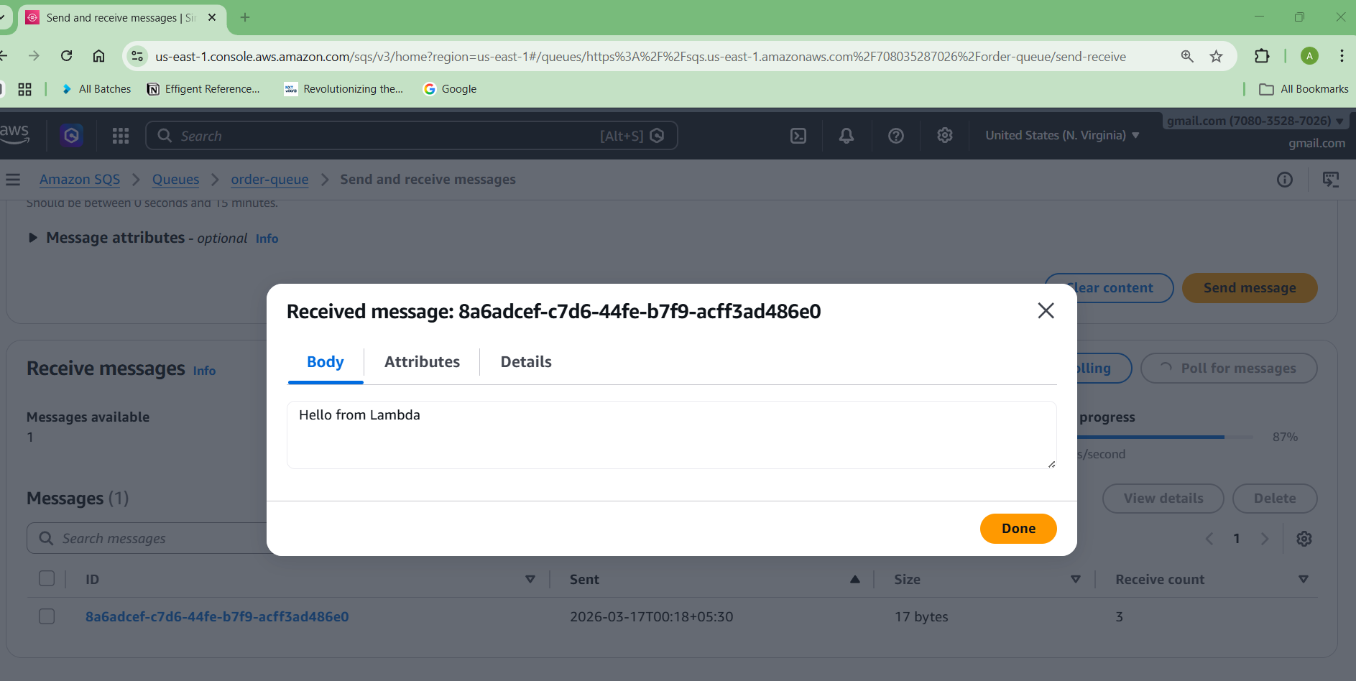

Full Flow
Producer
↓
Send message
↓
SQS Queue
↓
Consumer (your code)
↓
Receive message
↓
Process message
↓
Delete message

Amazon MQ

What is Amazon MQ ?
Amazon MQ is a managed message broker service that supports:
- ActiveMQ
- RabbitMQ
It is used when applications require traditional messaging protocols.

Key Features
- Managed message broker
- Supports AMQP, MQTT, STOMP
- Compatible with legacy systems
- Durable messaging

Use Cases
1. Legacy System Integration
Old enterprise systems often use:
JMS
AMQP
Amazon MQ supports them.

2. Enterprise Applications
Financial systems often rely on message brokers.
Example
Payment System
Inventory System
Notification Service

Architecture Flow
Producer Application
│
▼
Amazon MQ Broker
│
▼
Consumer Applications
Example
Order Service → MQ Broker → Payment Service

Execution Steps
Step 1
Open AWS Console
Step 2
Search
Amazon MQ
Step 3
Click
Create Broker
Step 4
Choose engine
ActiveMQ
or
RabbitMQ

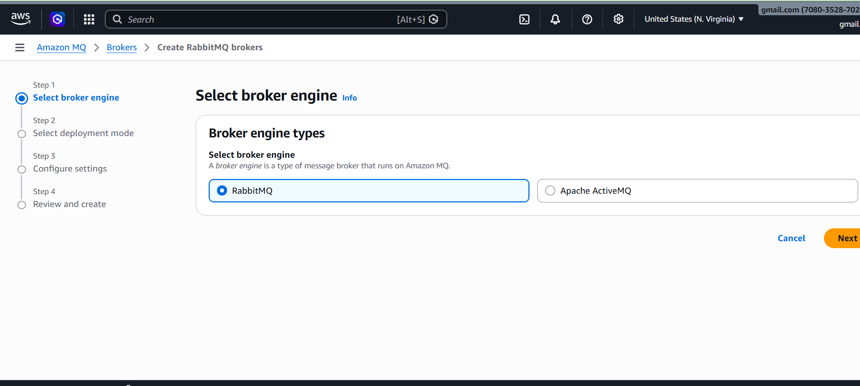
Step 5
1️⃣ Single-Instance Broker (Recommended for Demo / Practice)
✔ One broker in one Availability Zone
✔ Lower cost
✔ Used for development, testing, demos

When to choose this
- Learning Amazon MQ
- Doing demo projects
- Low traffic applications
👉 For your practice or demo, select:
Single-instance broker ✅
Then click Next.

2️⃣ Cluster Deployment (Production)
✔ Multiple brokers across multiple Availability Zones
✔ High availability
✔ Used for production workloads

When to choose
- Real company production systems
- High traffic applications
- Mission-critical messaging
But it is more expensive.

Next Screen (Step 3) You Will See
You will configure:
- Broker name
- Instance type
- Select instance type
- Example
- mq.t3.micro 0r mg7.Medium
- Username
- Password
- VPC
- Security group
Step 6
Configure security and networking
Step 7
Create broker

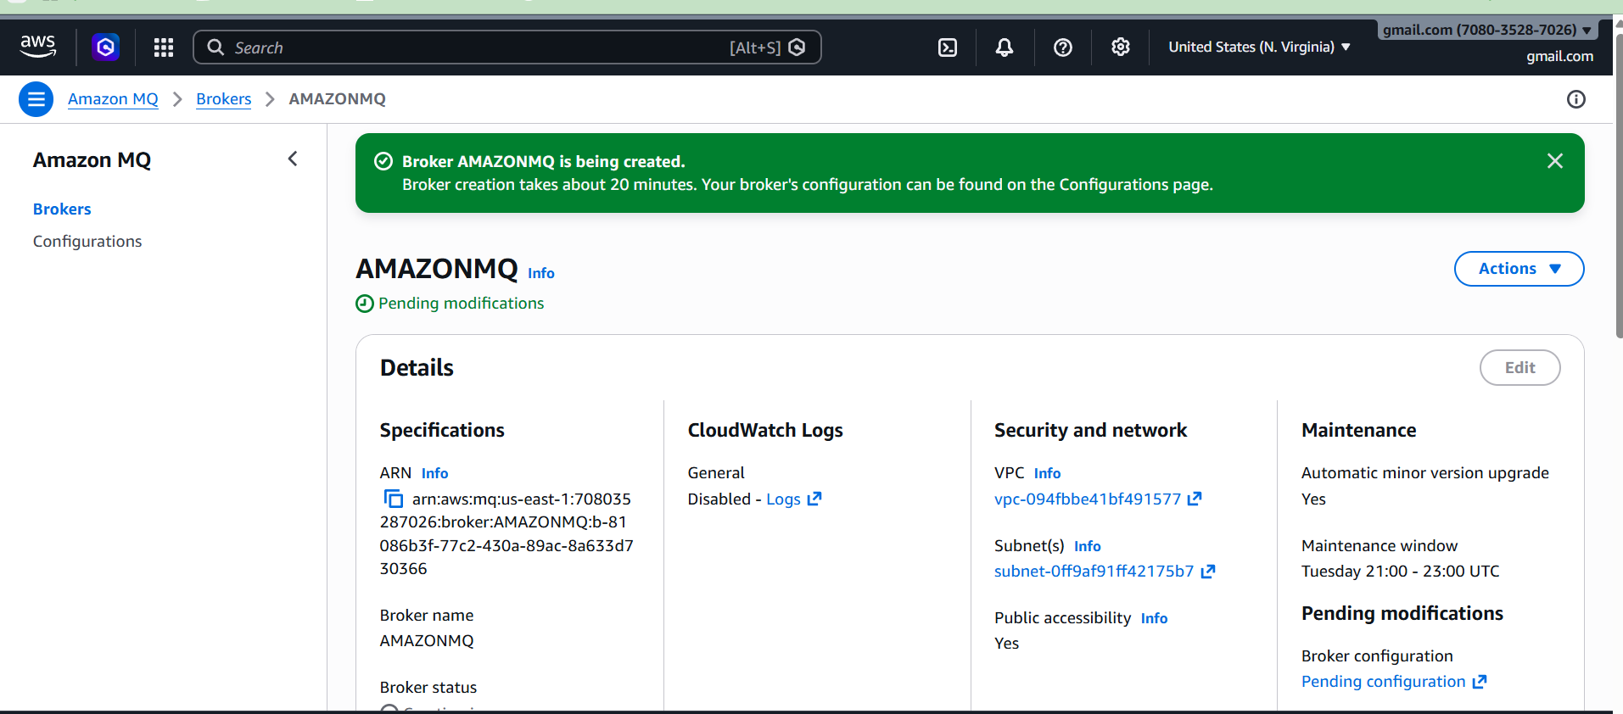
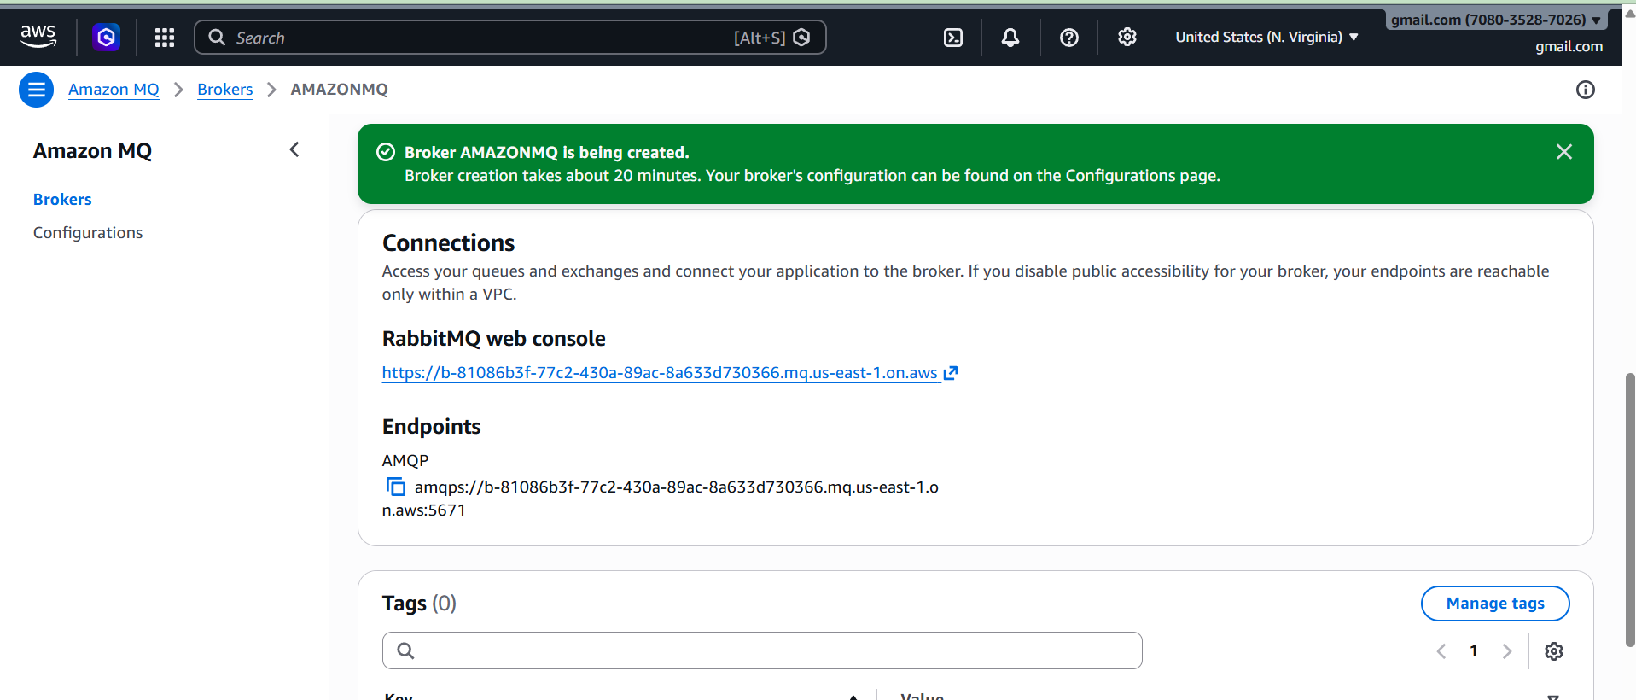

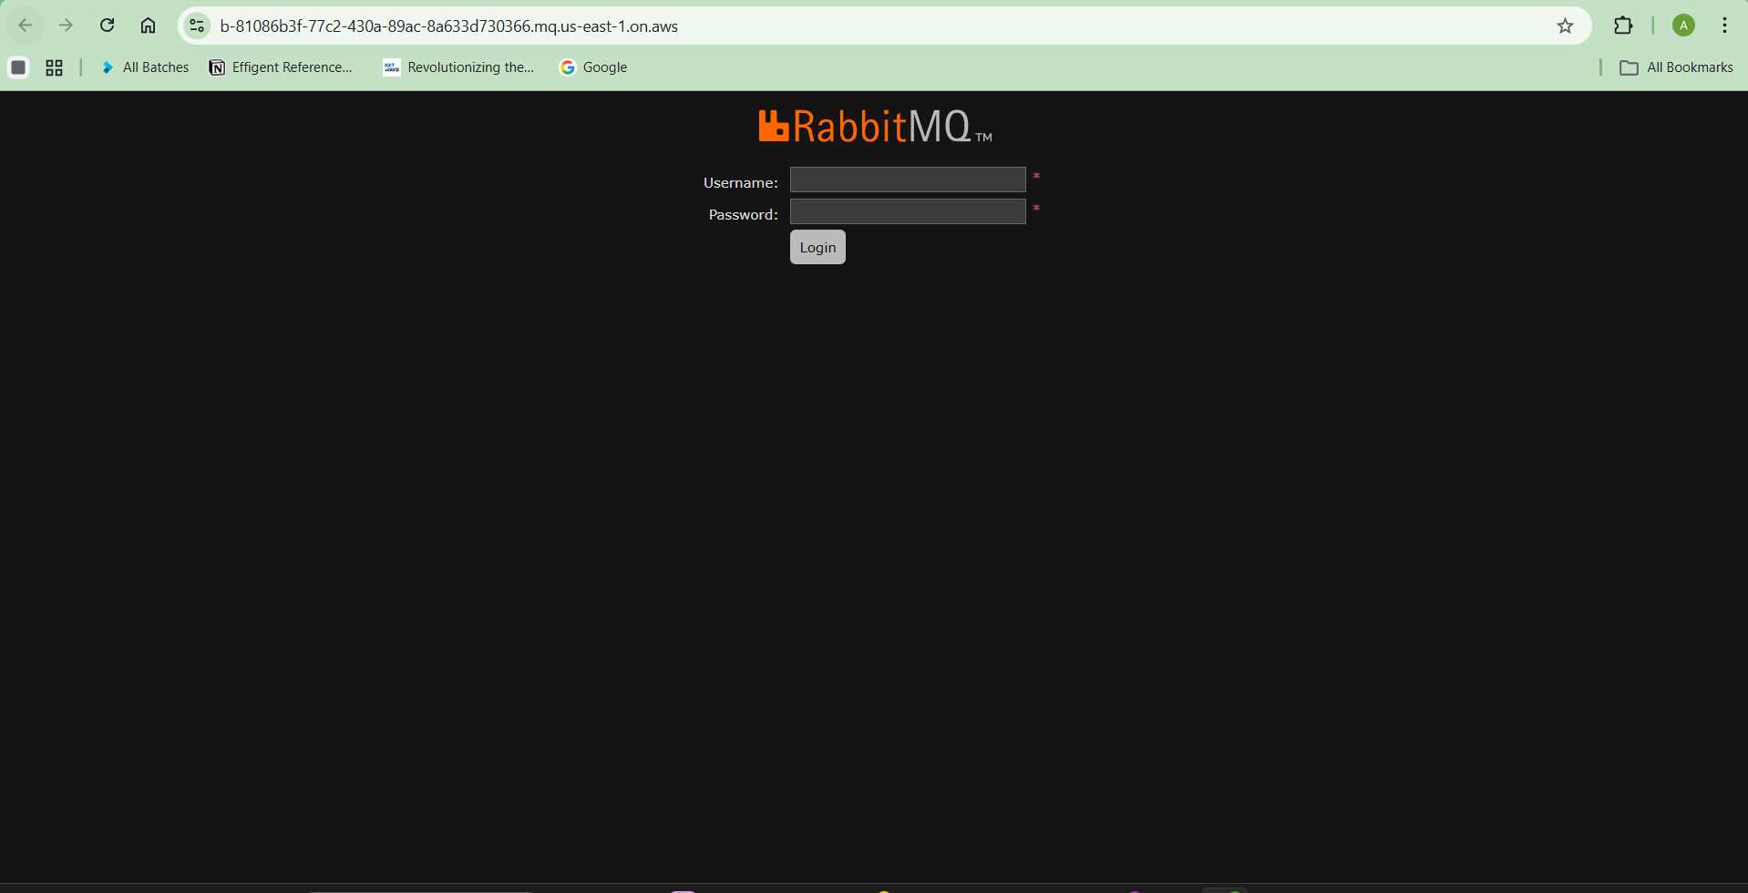
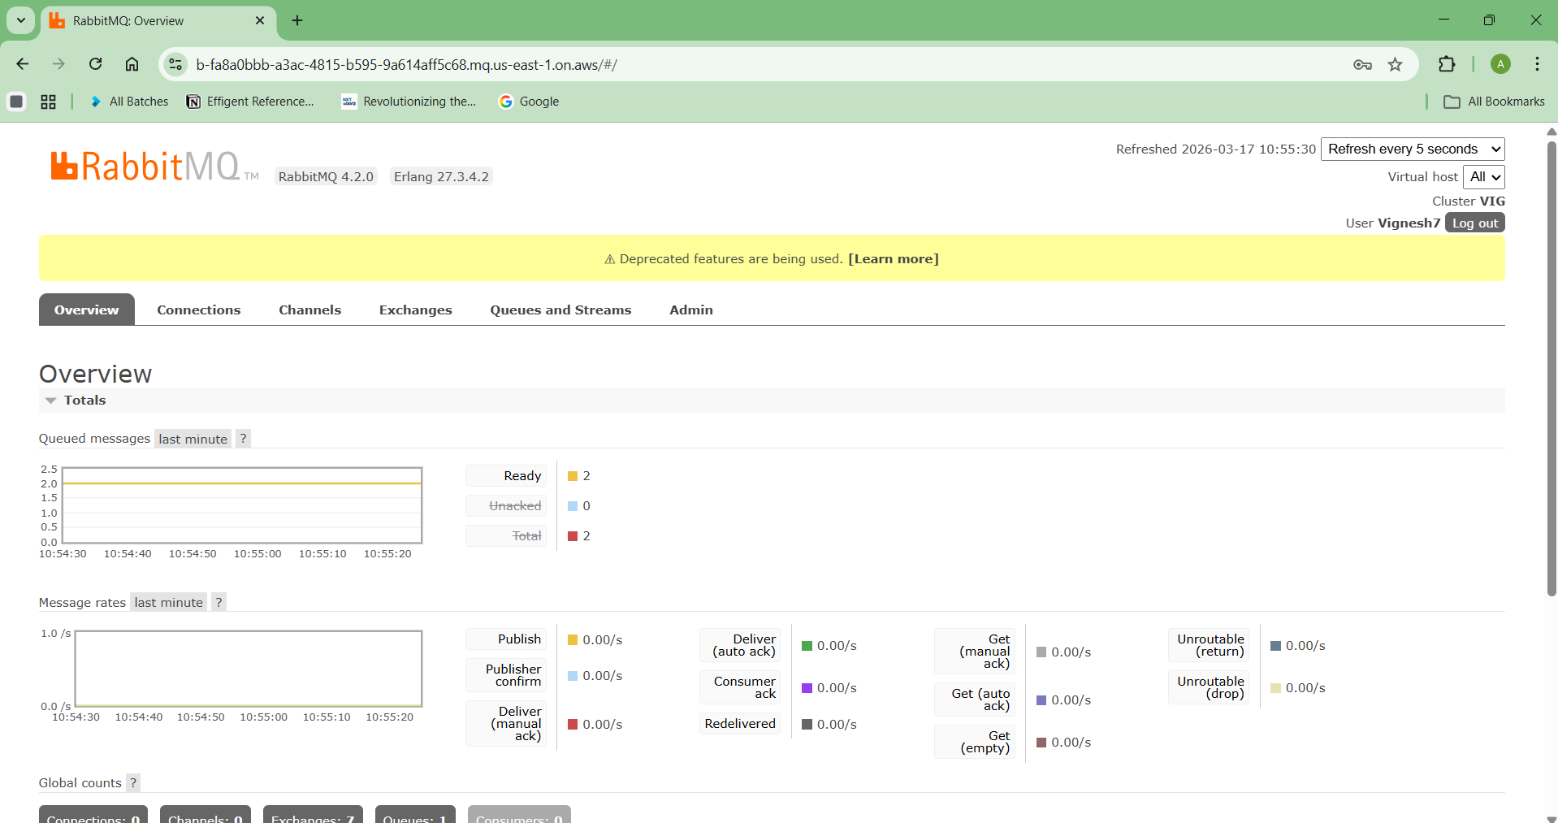

Difference Between SQS and Amazon MQ
Feature | SQS | Amazon MQ
Type | Queue Service | Message Broker
Protocol | AWS proprietary | AMQP, MQTT, STOMP
Management | Fully serverless | Managed broker
Use case | Microservices | Legacy systems
Scalability | Very high | Moderate

✅ Simple Rule
Use SQS for:
- Serverless apps
- Microservices
- Lambda architectures
Use Amazon MQ for:
- Legacy enterprise applications
- Applications requiring messaging protocols

Program 1 — Connect to Amazon MQ (RabbitMQ Broker)

Step 1 — Create a Folder

On your local system or EC2 / CloudShell run:

mkdir rabbitmq_lambda
cd rabbitmq_lambda

Step 2 — Install pika Inside This Folder

Run:

pip3 install pika -t .

Explanation:
Command | Meaning
pip3 install | installs Python package
pika | RabbitMQ client
-t . | installs into current folder

After this you will see files like:

pika/
pika-1.x.dist-info/

inside the folder.

Step 3 — Add Lambda Code

Create file:

nano lambda_function.py

Paste this example:

import pika
def lambda_handler(event, context):
connection = pika.BlockingConnection(
pika.ConnectionParameters('BROKER_URL')
)
channel = connection.channel()
channel.queue_declare(queue='task_queue')
channel.basic_publish(
exchange='',
routing_key='task_queue',
body='Hello from Lambda'
)
connection.close()
return {
'statusCode': 200,
'body': 'Message sent to Amazon MQ'
}

Save.

Step 4 — Install Required Library (pika)

Your Lambda code uses pika, which is the Python client for RabbitMQ / Amazon MQ.
So we must install it and package it with the Lambda ZIP.

1️⃣ Create a folder for Lambda package

In your terminal:

mkdir lambda_mq
cd lambda_mq

2️⃣ Install pika library inside this folder

Run:

pip3 install pika -t .

This downloads the pika package into the current folder.

After installing, check:

ls

You should see something like:

pika/
pika-1.3.2.dist-info/

3️⃣ Copy your Lambda file into the folder

Move the file you created earlier:

mv ../lambda_function.py .

Now check:

ls

You should see:

lambda_function.py
pika/
pika-1.3.2.dist-info/

4️⃣ Create ZIP package for Lambda

Run:

zip -r lambda_mq.zip .

This creates:

lambda_mq.zip

✅ Now you have the Lambda deployment package.

Step 5 — Upload ZIP to AWS Lambda
- Open AWS Console
- Go to Lambda
- Select your Lambda function
- Click Upload from → .zip file
- Upload lambda_mq.zip
- Click Deploy

Step 6 — Replace BROKER_URL

In your code change:

pika.ConnectionParameters('BROKER_URL')

to your Amazon MQ broker endpoint like:

pika.ConnectionParameters('b-xxxxxxxx.mq.us-east-1.amazonaws.com')

✅ After this, Test the Lambda function.

Step 7 — Check the ZIP File Path

First confirm the file exists.

ls

or

pwd

Example output:

/home/ec2-user/lambda_mq
lambda_mq.zip

So the full path will be:

/home/ec2-user/lambda_mq/lambda_mq.zip

Step 8 — Download ZIP from Cloud to Your Computer

Method 1 — If using AWS CloudShell

Run:

ls

You will see:

lambda_mq.zip

Then:
- Click Actions
- Click Download file
- Enter file path:

lambda_mq/lambda_mq.zip
- Click Download

Method 2 — If using EC2 Instance

Use scp command from your local system.

Example:

scp -i key.pem ec2-user@EC2_PUBLIC_IP:/home/ec2-user/lambda_mq/lambda_mq.zip .

Example:

scp -i mykey.pem ec2-user@54.210.xx.xx:/home/ec2-user/lambda_mq/lambda_mq.zip .

The ZIP will download to your computer.

Method 3 — If using VS Code / Remote SSH

Just:
- Open Explorer
- Navigate to folder
- Right click lambda_mq.zip
- Click Download

✅ After downloading:

Go to AWS Lambda → Upload from ZIP → Deploy

This AWS Lambda Python program sends a message to Amazon MQ (RabbitMQ) using a secure AMQP connection.

import pika

import ssl

def lambda_handler(event, context):

username = "Vignesh7"

password = "8247776210aA@"

credentials = pika.PlainCredentials(username, password)

ssl_context = ssl.create_default_context()

parameters = pika.ConnectionParameters(

host="b-fa8a0bbb-a3ac-4815-b595-9a614aff5c68.mq.us-east-1.on.aws",

port=5671,

virtual_host="/",

credentials=credentials,

ssl_options=pika.SSLOptions(ssl_context)

)

connection = pika.BlockingConnection(parameters)

channel = connection.channel()

channel.queue_declare(queue="test")

channel.basic_publish(

exchange="",

routing_key="test",

body="Hello from Lambda Amazon MQ"

)

connection.close()

return {

"statusCode": 200,

"body": "Message sent to Amazon MQ"

}

Architecture Flow
AWS Lambda
│
│ AMQPS (TLS) Port 5671
▼
Amazon MQ (RabbitMQ Broker)
│
▼
Queue : test
│
▼
Message stored

This is called Event-Driven Architecture.

Step-by-Step Explanation
1. Import Libraries
import pika
import ssl
- pika → Python client library for RabbitMQ (AMQP protocol)
- ssl → used to create a secure TLS connection

Real-World Use Cases
This pattern is used for:
• microservices communication
• order processing systems
• event-driven architectures
• background task processing

2. Lambda Handler Function
def lambda_handler(event, context):
This is the entry point of the AWS Lambda function.
AWS Lambda automatically executes this function.

3. RabbitMQ Credentials
username = "Vignesh777"
password = "824777aA@”
These credentials are used to authenticate with the Amazon MQ RabbitMQ broker.

4. Create Authentication Object
credentials = pika.PlainCredentials(username, password)
This creates a RabbitMQ login credential object.

5. Create Secure SSL Context
ssl_context = ssl.create_default_context()
Amazon MQ requires TLS encryption, so this creates a secure SSL configuration.

6. Connection Parameters
parameters = pika.ConnectionParameters(
host="b-fa8a0bbb-a3ac-4815-b595-9a614aff5c68.mq.us-east-1.on.aws",
port=5671,
virtual_host="/",
credentials=credentials,
ssl_options=pika.SSLOptions(ssl_context)
)
This defines how to connect to RabbitMQ.
Parameter | Meaning
host | Amazon MQ broker endpoint
port | 5671 (secure AMQP port)
virtual_host | RabbitMQ namespace
credentials | login details
ssl_options | enables TLS

7. Connect to RabbitMQ
connection = pika.BlockingConnection(parameters)
channel = connection.channel()
- Establishes connection to the RabbitMQ broker
- Creates a channel used for messaging

8. Declare Queue
channel.queue_declare(queue="test")
Creates a queue named test if it does not already exist.

9. Send Message
channel.basic_publish(
exchange="",
routing_key="test",
body="Hello from Lambda Amazon MQ"
)
This publishes a message to the test queue.
Message content:
Hello from Lambda Amazon MQ

10. Close Connection
connection.close()
Closes the RabbitMQ connection after sending the message.

11. Return Response
return {
"statusCode": 200,
"body": "Message sent to Amazon MQ"
}
Returns a successful response from the Lambda function.

2) Python Consumer Program (Receive Messages from Amazon MQ)

import pika
import ssl
username = "YOUR_USERNAME"
password = "YOUR_PASSWORD"
credentials = pika.PlainCredentials(username, password)
ssl_context = ssl.create_default_context()
parameters = pika.ConnectionParameters(
host="b-fa8a0bbb-a3ac-4815-b595-9a614aff5c68.mq.us-east-1.on.aws",
port=5671,
virtual_host="/",
credentials=credentials,
ssl_options=pika.SSLOptions(ssl_context)
)
connection = pika.BlockingConnection(parameters)
channel = connection.channel()
channel.queue_declare(queue='test')
def callback(ch, method, properties, body):
print("Received message:", body.decode())
channel.basic_consume(
queue='test',
on_message_callback=callback,
auto_ack=True
)
print("Waiting for messages...")
channel.start_consuming()

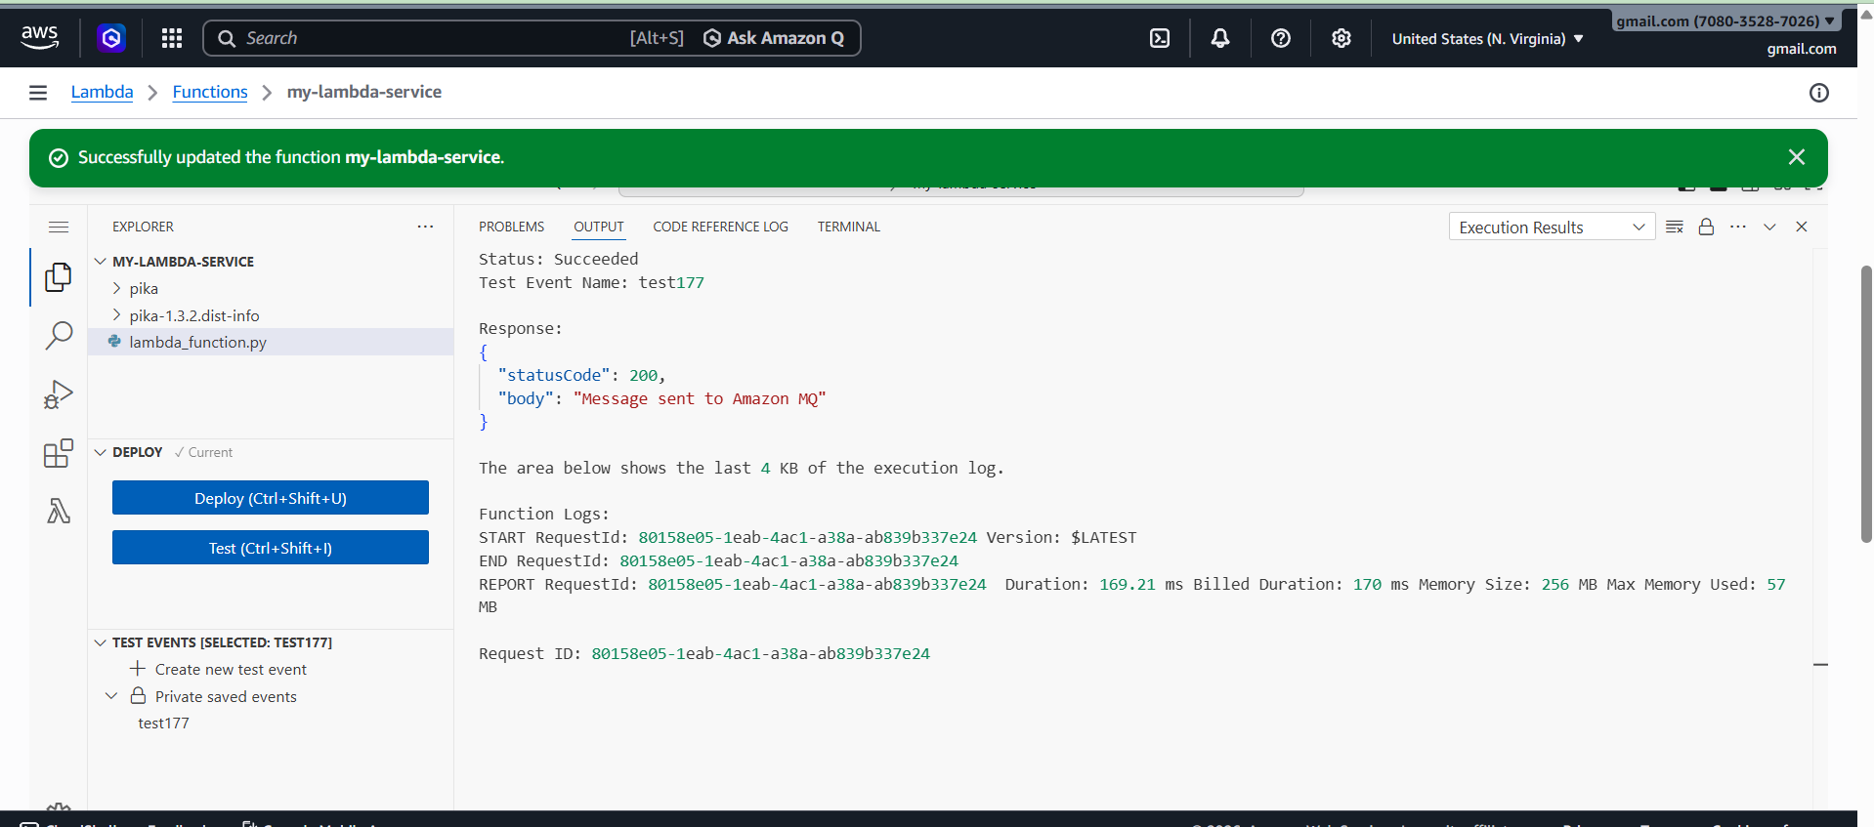

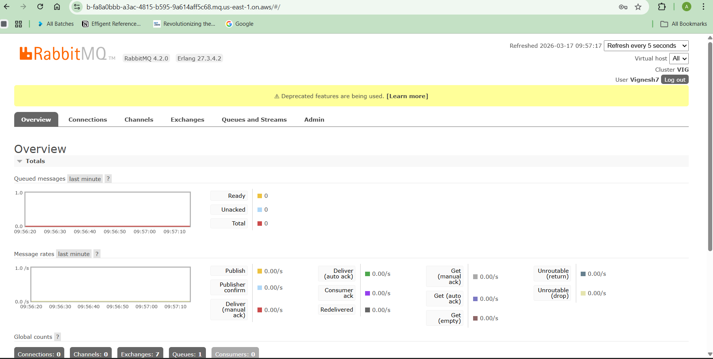

Expected Output
When Lambda sends a message, you will see:
Waiting for messages...
Received message: Hello from Lambda Amazon MQ

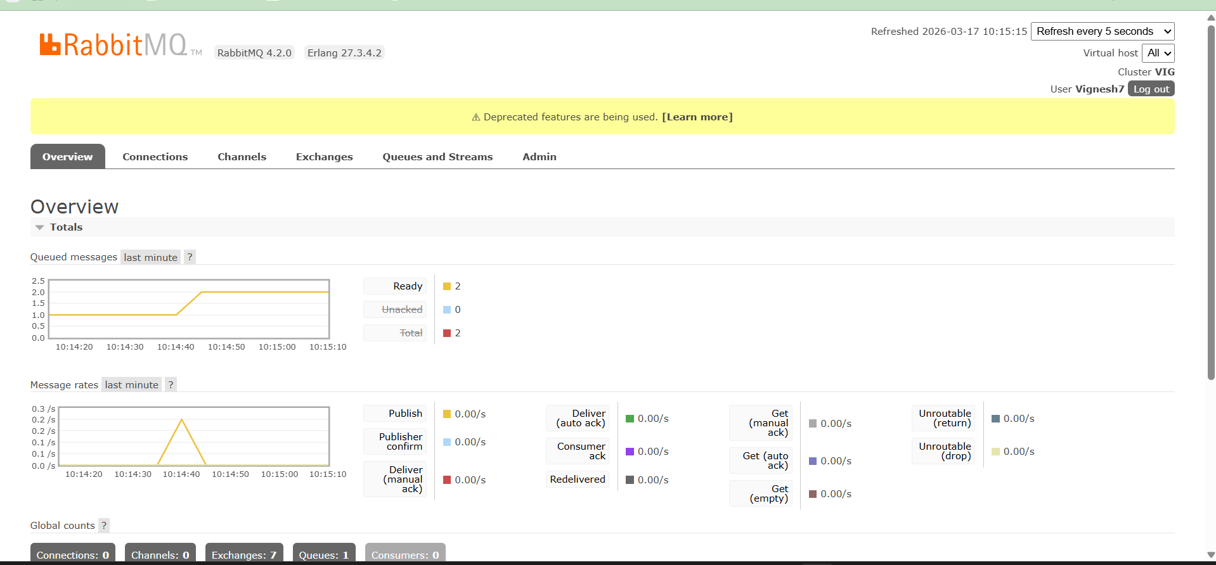

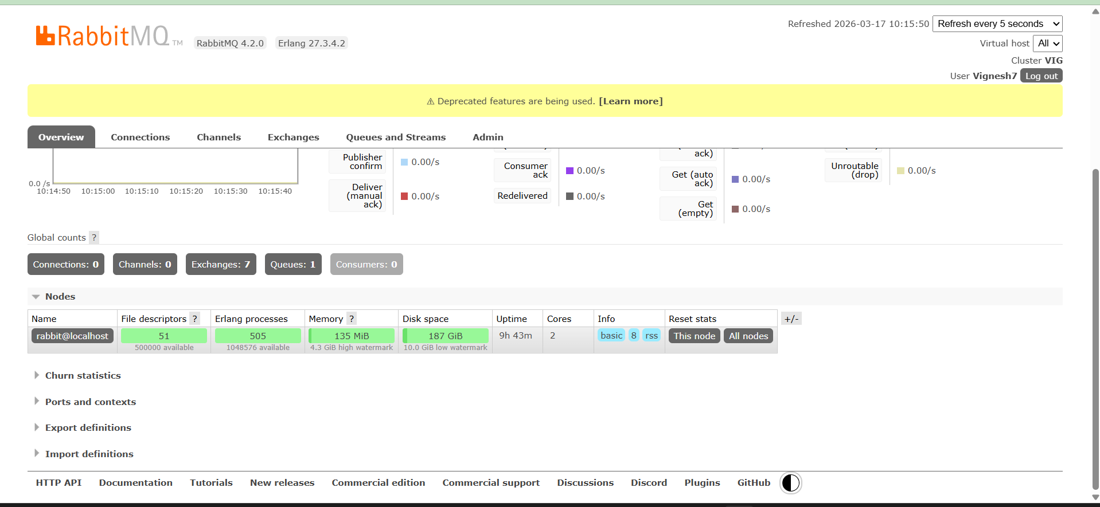

Architecture Now
You now have a complete messaging system:
Lambda (Producer)
│
▼
Amazon MQ (RabbitMQ)
│
▼
Python Consumer

